Module 2 Lesson 7
BUSINESS PROPOSAL: PERSUASION THROUGH STRUCTURE
Criteria  Critical Analysis (CA)  Delivery (D) Audience Engagement (AE)  Organisation (O) | Learning Outcomes:  - Recall information from a sample outline for “Section 3: Evaluation of Current Market and Industry Needs”  - Examine and evaluate possible sources for “Section 3: Evaluation of Current Market and Industry Needs”  - Brainstorm, outline and present ideas for your own “Section 3: Evaluation of Current Market and Industry Needs”
Lesson purpose
In one of the previous lessons, we explored the purposes and organization of "Section 3: Evaluation of Current Market and Industry Needs." Today, we will build on that foundation by focusing on how to develop and support your ideas. You will learn to brainstorm effectively and outline your thoughts, using the given sample as a guide, before presenting your ideas to the class on your own Section 3.

Warm-up activity

You will need to write "Section 3: Evaluation of Current Market and Industry Needs” for the business proposal. This information will also be useful for the ‘Problem’ section of your Innovators’ Pitch. In preparation for Writing "Section 3: Evaluation of Current Market and Industry Needs” and presenting the Problem section of the Pitch, let’s start by answering the following questions:
- What is your project group’s chosen business communication problem?
- What is your proposed solution?
- For Section 3, what initial market and/or industry needs for your proposed solution have you identified? Write about them briefly in 100 words.
- Which sources are you going to use to support these market and/or industry needs? Identify 3 sources and list them in APA style (7th edition).
E.g,. HSBC. (n.d.). Age-friendly banking and services for the elderly. https://www.hsbc.com.hk/community-banking/age-friendly/#:~:text=Banking%20with%20us%20simpler%20and%20faster&text=We%20also%20have%20Community%20Care,our%20Smart%20Seniors%20for%20assistance

Activity 1 | Identifying & Understanding “Section 3: Evaluation of Current Market and Industry Needs”
In a previous lesson, a sample “Section 3: Evaluation of Current Market and Industry Needs” was given. However, perhaps you are feeling unsure of how to approach this section for your own project. To make it easier, see a mind map of the sample below:
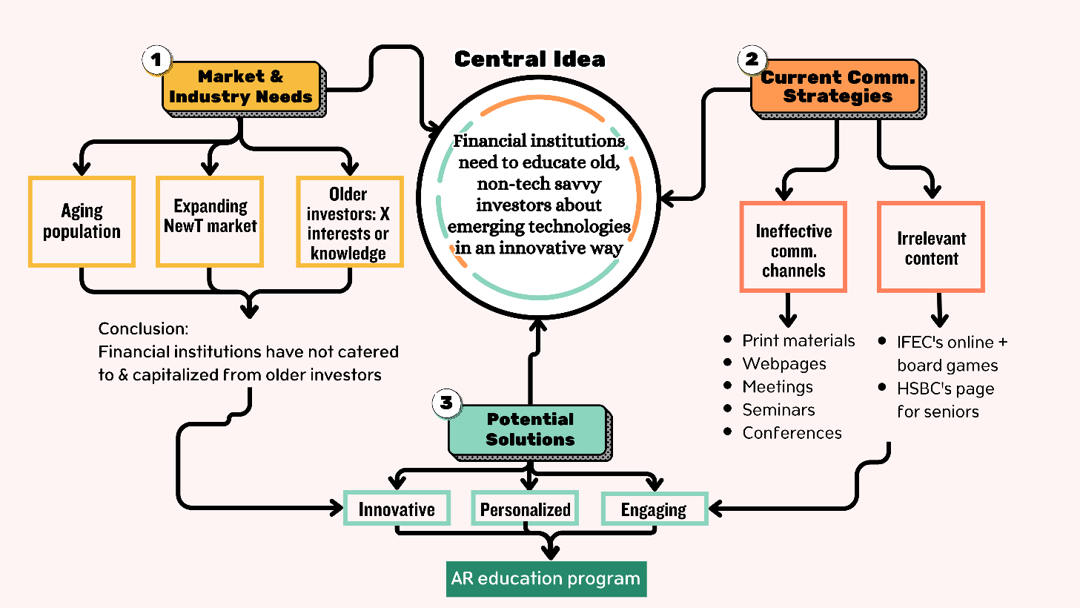
Find some useful questions and the sample’s answers that can be used to help brainstorm ideas:
Questions | Sample’s answers
Sub-section 3.1: Market & Industry Needs
- In your research context, what recent changes or emerging trends in the market have caused or worsened your chosen business communication problem? These trends can be:  - demographic  - technological  - economic  - environmental  - social  - political  - industry-specific | My research context:  Financial investment market in Hong Kong  My business communication problem:  Older, non-tech savvy investors don’t know much about and don’t invest in emerging technologies  Recent trends:  - demographic: aging population  - technological + economic: growing importance of emerging technologies  - industry specific: banks don’t know how to approach these investors effectively
- Who are the major stakeholders in your research context? What do they need under these trends? | Major stakeholders:  - older, non-tech savvy investors  - financial institutions  Their needs:  - investors: to learn about the potential of emerging technologies and how to invest in them  - financial institutions: to attract these clients to invest in these technologies
- What is the current market size and growth potential for the problem or solution you are focusing on? | Current market size:  - no such data about the number of older investors in Hong Kong  - projections show the growth of seniors in the near future  Growth potential:  - existing data about the impact of emerging technologies  - HK government’s plan to invest in them
- What knowledge or skills does your target market lack that would enable them to make better use of your proposed solution? | Knowledge / skills gap:  Financial institutions do not adopt innovative, easy-to-understand, personalized education programs for older investors
Sub-section 3.2: Current Communication Problems
- What are the existing solutions or products in the market addressing major stakeholders’ needs? | Existing solutions:  a. Formats  - Print materials (e.g. brochures)  - Company websites  - In-person meetings  - Seminars / talks / conferences  b. Content  - Anti-scams or anti-fraud  - Estate planning (e.g., lawyers for wills)
- How effective are these solutions, and what gaps or shortcomings do they have? | Effectiveness:  - ineffective  - recent official surveys show very low interest and lack of knowledge of older investors  Shortcomings:  - formats: non-engaging, difficult to understand, generic  - content: not related to what emerging technologies are, nor why and how to invest on them
Sub-section 3.3: Call for an innovative solution
- How to overcome the gaps / shortcomings of existing solutions? | Approach to solution:  A personalized, easy-to-understand, engaging financial literacy approach by financial institutions
- What is a specific innovation that can cater to the major stakeholders’ needs in this communication context? | The innovative solution:  An AR education program

Answer the following questions about the sample “Section 3: Evaluation of Current Market and Industry Needs” with your group:
Research context of the sample:
Financial investment market in Hong Kong
The business communication problem:
Older, non-tech savvy investors do not know much about and do not invest in emerging technologies
Sub-section 3.1: Market & Industry Needs
1. What are the recent trends?
2. Who are the major stakeholders and what are their needs?
3. What is the current market size and growth potential?
4. What knowledge or skills does the target market lack that would enable them to make better use of his proposed solution?
Sub-section 3.2: Current Communication Problems
5.. What are the existing solutions or products in the market addressing major stakeholders’ needs?
6. How effective are these solutions, and what gaps or shortcomings do they have?
Sub-section 3.3: Call for an innovative solution
7. How could the gaps / shortcomings of existing solutions be overcome?
8. What is a specific innovation that can cater to the major stakeholders’ needs in this communication context?

Activity 2 | Using Sources in “Section 3: Evaluation of Current Market and Industry Needs”
Which sources are you going to use to support these market and/or industry needs? Are they appropriate and credible? Compare your sources with your classmate(s).
Source (reference) | Type | Appropriate/credible? | Why/why not?
1.
2.
3.

Activity 3 | Brainstorming and outlining ideas for your own “Section 3: Evaluation of Current Market and Industry Needs”
Part 1: Based on your research topic, work with your project group and answer the questions briefly by filling out the following table. Include in-text citations where you are planning to use sources.
Questions | Your answers
Sub-section 1: Market & Industry Needs
A. In your research context, what recent changes or emerging trends in the market have caused or worsened your chosen business communication problem? These trends can be:  - demographic  - technological  - economic  - environmental  - social  - political  - industry-specific) | My research context:  My business communication problem:  Recent trends:
B. Who are the major stakeholders in your research context? What do they need under these trends? | Major stakeholders:  Their needs:
C. What is the current market size and growth potential for the problem or solution you are focusing on? | Current market size:  Growth potential:
D. What knowledge or skills does your target market lack that would enable them to make better use of your proposed solution? | Knowledge / skills gap:
Sub-section 2: Current Communication Problems
E. What are the existing solutions or products in the market addressing major stakeholders’ needs (→ Q2)? | Existing solutions or products:
F. How effective are these solutions, and what gaps or shortcomings do they have? | Effectiveness:  Gaps or shortcomings:
Sub-section 3: Call for an innovative solution
G. How to overcome the gaps / shortcomings of existing solutions? | Approach to solution:
H. What is a specific innovation that can cater to the major stakeholders’ needs in this communication context? | The innovative solution:

Part 2: With your group, present and explain the different sub-sections of Section 3: Evaluation of Current Market and Industry Needs for your own research context.

Reflection
What are the benefits of using a structured outline when drafting a section of a business proposal? How does it improve the overall quality of your writing? What challenges did you encounter while brainstorming and outlining your own Section 3? How did you overcome them, and what strategies will you use in the future to tackle similar tasks?

